Name | Instrument | Amp | Misc
Meg Hudson | Vocals | No | 1 XLR
Greg Hudson | Guitar | Yes | Power Supply
Luke Sessum | Bass | Yes | Power Supply
 | Drums | No | Rug? Kick Mic
Tech Rider – Drive Thru Society

The band will supply:

- 1 standard drum kit
- Carpet (if not provided by the venue)
- 1 Guitar Amp Head
  - Mesa Boogie Triple Rectifier
- 1 Guitar speaker cabinet
- Guitars/Bass
- 1 Bass amp head
  - Mesa M6 Carbine
- 1 Bass Cabinet
  - SWR Megoliath 8x10
- 1 Wireless Mic
  - Sennheiser EW 100G3
- Cords for all the above instruments (guitars, bass, vocal)

The Venue will supply:
- A sound system
- A kick drum mic (if they plan to mic the drums)
- A snare drum mic (if they plan to mic the drums)
- A Guitar Mic
- 2 floor monitors at the front of the stage
- 1 floor monitor by the drummer
- Carpet for the drummer (if possible, but not necessary)
**if the venue is unable to provide any of the equipment above, please contact Greg Hudson (drivethrusocietyband@gmailcom) so we can coordinate other arrangements.**

Linkes to our music:
Reverbnation - https://www.reverbnation.com/drivethrusociety
Youtube - https://www.youtube.com/channel/UCzRn5S51ptEv3S80locofkg

Stage Plot – We run IEM’s so the monitors are back-up

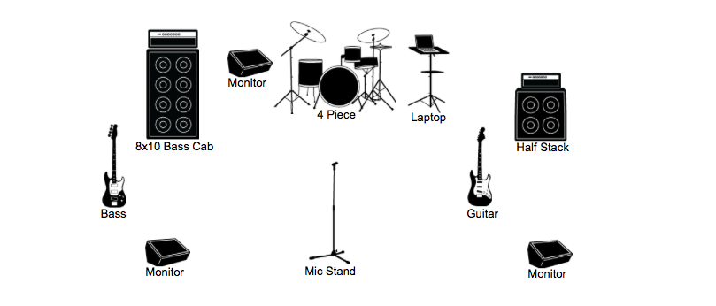

Contact info:

Greg Hudson
drivethrusocietyband@gmail.com
817-219-5844

Thank you for doing this! A band is nothing without a fabulous sound engineer! :D

